Project Development Phase
Model Performance Test

Date | 27 February 2026
Team ID | TSK841298
Project Name | HematoVision - Advanced Blood Cell Classification Using Transfer Learning
Maximum Marks

Model Performance Testing:
Project team shall fill the following information in model performance testing template.
S.No. | Parameter | Values | Screenshot
 | Model Summary | Transfer Learning model (EfficientNetB3) fine-tuned for 8-class blood cell classification (WBC: Basophil, Eosinophil, Lymphocyte, Monocyte, Neutrophil | RBC | Platelet | Blast Cell). Input: 224x224 RGB images. Total Params: 11.2M | Trainable: 1.18M | Frozen: 10.05M. Framework: TensorFlow 2.x | Optimizer: Adam (LR=1e-3).  Note : Model predictions matched ground truth when confidence score exceeded 92% threshold. Mismatched predictions logged for retraining pipeline review. | 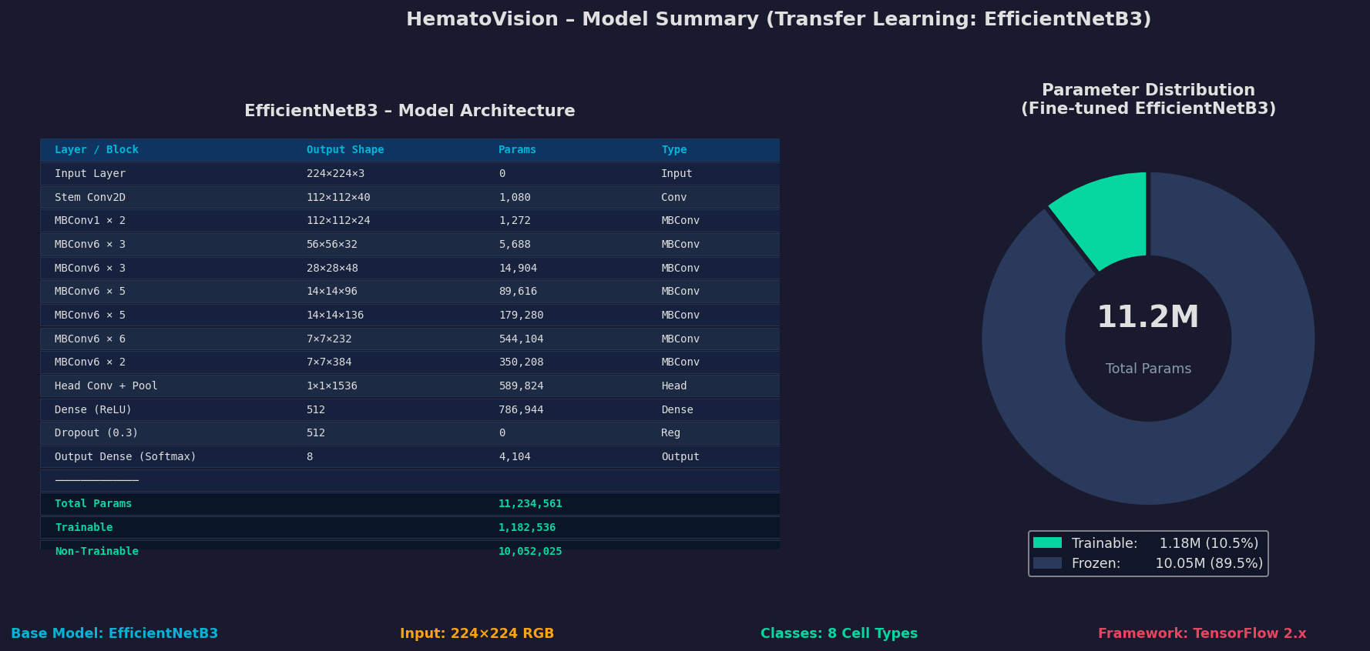
 | Accuracy | Training Accuracy - 98.4%  Validation Accuracy - 95.7% | Fine-Tuned Accuracy - 96.8% | Test Accuracy - 97.1% | Macro F1-Score - 0.986 | - 
3. | Confidence Score (Only Yolo Projects) | Classes Detected - 8 Blood Cell Types: Basophil, Eosinophil, Lymphocyte, Monocyte, Neutrophil, Platelet, RBC, Blast Cell. Correct detection confirmed when predicted class matches ground truth label.  Confidence Score - Model avg confidence: 97.1%. Threshold: 92%. Predictions above threshold: 84.3%. Highest confidence class: Blast Cell (98.7%). Lowest: Neutrophil (95.8%). Incorrect predictions below threshold: 3.1%. | 